Gedling Borough Council
Community Infrastructure Levy (CIL)

Infrastructure Funding Statement 2019/20

Published December 2020

1 INTRODUCTION
Welcome to the Gedling Borough Council Infrastructure Funding Statement. This statement sets out this year’s income and expenditure relating to the Community Infrastructure Levy (CIL) and Section 106 (s106) Agreements.
As a result of the recent changes made by the Community Infrastructure Levy (Amendment) (England) (No. 2) Regulations 2019, Local Authorities are required to produce Infrastructure Funding Statements on an annual basis.
Income collected from the CIL and / or s106 (collectively known as ‘planning obligations’ or ‘developer contributions’) is used to help fund the provision of infrastructure which is necessary to support and enable development and growth within the Borough.
Sections 2 and 3 of this statement will provide details of the progress in relation to the collection and expenditure of income generated through the CIL and s106 respectively for the last financial year.
Section 4 sets out the planned future expenditure of income generated through these mechanisms over the next reporting period.
1.1 Community Infrastructure Levy & Section 106 Agreements
The Community Infrastructure Levy is a tariff-based charge on the development of new floorspace within the borough. Monies collected through the CIL can be used to fund a wide range of infrastructure (e.g. roads, medical practices and the provision of open space) that is required to meet the future growth needs of the borough.
The Gedling Borough Community Infrastructure Levy (CIL) Charging Schedule was approved by Full Council on 15th July 2015 and came into effect on 16th October 2015. Planning applications decided on or after 16th October 2015 may therefore be subject to CIL.
Section 106 agreements are private agreements made between local authorities and developers and can be attached to a planning permission to ensure that a certain development, which may otherwise be unacceptable in planning terms, meets the local planning authorities policy requirements. Typical forms of Section 106 Obligations include:
- Site-specific financial contribution;
- Non-financial obligations; and
- Provision of on-site affordable housing.
1.2 Summary of Headlines within Statement
Table 1. Key Headlines from the Statement.
Summary of CIL Receipts
A total of £423,522.65 in CIL receipts were collected during the financial year 2019/20.

A total of £1,276,677 receipts were retained at the end of the financial year 2019/20. Of this, £1,229,538 is to be used towards the provision of Strategic Infrastructure within the Borough, whilst £47,140 remains for Infrastructure projects identified through the Neighbourhood portion of the CIL.

A total of £23,807.91 was passed to Local Parishes during 2019/20 in accordance with Regulations 59A.

A total of £21,176 was allocated to cover the administrative costs of implementing and monitoring the CIL during 2019/20.

Summary of Section 106 Contributions
During the 2019/20 financial year £239,850.75 was collected in capital contributions through Section 106 Obligations.

A total of £405,733.50 capital contributions have been spent on infrastructure within Gedling Borough Council during the 2019/20 financial year.

At the end of the financial year 2019/20, £1,792,734 worth of capital contributions were retained by Gedling Borough Council.

2 COMMUNITY INFRASTRUCTURE LEVY
The amount of CIL payable depends on where the development is located within the borough, the type of use the development comprises of, and the net additional increase in floorspace (£ per Sqm).
Gedling Borough Council’s Charging Schedule currently identifies two different types of Uses which are liable for the CIL. Retail development chargeable by a flat rate across the borough whilst new residential development is split into three different zones. The Charging Schedule and Map of the different zones are available to view from our website at https://www.gedling.gov.uk/cil/.
Alongside the Charging Schedule Gedling Borough Council also adopted a Regulation 123 List in accordance with the regulations in force at the time. Expenditure of the Strategic CIL receipt was approved for the following infrastructure projects:
- The Gedling Access Road (GAR);
- Secondary School Contributions for Gedling Colliery / Chase Farm and Top Wighay Farm strategic sites; and
- The Gedling Country Park Visitors Centre.
Unlike Section 106 Agreements, the CIL payable is a fixed rate which is mandatory and non-negotiable. The charge becomes payable upon the commencement of development.
2.1 CIL Income
Table 2 below provides a cumulative total of the receipts retained at the end of each year since Gedling Borough Council adopted the CIL in 2015.
Table 2. Cumulative Total CIL Receipts Retained (to the nearest £)
Year | Income
2015/16 | £0
2016/17 | £36,171
2017/18 | £420,148
2018/19 | £1,038,139
2019/20 | £1,276,677
Gedling Borough Council adopted the CIL on 16th October 2015. In accordance with the Community Infrastructure Levy (Amendment) (England) (No. 2) Regulations 2019, any planning application which was determined prior to this date is not chargeable. It is for this reason, along with a gap between the granting of permission and implemented, that no receipts were collected during the 2015/16 financial year.
Of all the receipts collected to date, the greatest amount of CIL collected from a singular development relates to the first phase of the Chase Farm development which has currently generated £1,162,609.88 in CIL Receipts. The receipts from this development explain the increase in CIL collected during the 2018/19 financial year.
2.2 Breakdown of CIL for 2019/20
During the reported year 2019/20, 23 Demand Notices were issued totalling £382,125.00 in CIL Receipts. To date £240,552.83 of these receipts have been collected. The collection of the remaining sums from these Demand Notices will be reported in the next annual Infrastructure Funding Statement.
In total there has been £423,522 collected in CIL receipts from across 12 different developments. A summary of the receipts collected during the year is detailed in Table 3 below.
Table 3. Annual Breakdown of CIL Receipts 2019/20 (1st April 2019 - 31st March 2020)
Total Receipts Collected | £423,522.65
Receipts Passed to Local Parishes | £23,807.91
Administration CIL | £21,176.13
CIL Receipts Retained at End of Year | £1,276,677

Of the receipts which were collected during 2019/20, £332,116 is to be spent on strategic infrastructure projects that were identified on the Regulation 123 List while £70,230 is to be spent in the locality it was collected as part of the neighbourhood portion of the CIL. A total of £23,807.91 of the Neighbourhood portion of the CIL has been passed directly to the Local Parishes in accordance with Regulation 59A of the Community Infrastructure Levy (Amendment) (England) (No. 2) Regulations 2019.
£21,176 (5%) has been set aside to cover the administration costs as permitted by the Community Infrastructure Levy (Amendment) (England) (No. 2) Regulations 2019.
In 2019 projects which were identified as suitable for funding through the Neighbourhood portion of the CIL, in accordance with Regulation 59F of the Community Infrastructure Levy (Amendment) (England) (No. 2) Regulations 2019, were awarded a total of £140,000.
A total of £1,276,677 in CIL receipts were retained at the end of the financial year 2019/20.
2.2.1 Strategic CIL
Since its adoption of CIL, Gedling Borough Council has collected £1,229,538 towards the provision of its strategic projects.
Table 4. Annual Strategic CIL Collected (to the nearest £)
Year | Income
2015/16 | £0
2016/17 | £33,695
2017/18 | £333,580
2018/19 | £530,147
2019/20 | £332,116
Total | £1,229,538

Following its introduction in 2015, the strategic portion of the CIL collected has been retained for the construction of Gedling Access Road (GAR) which remains the Council’s first priority in terms of key infrastructure within the Borough. The Borough Council has agreed to make a contribution of up to £4.48 million from the Strategic CIL receipt.
The GAR is a new 3.8km single carriageway road which will provide a link between the B684 Mapperley Plains and the A612 Trent Valley Road / Nottingham Road. The provision of this piece of infrastructure is vital to support planned growth in this area. Construction of the GAR began in January 2020 and is expected to be completed in Autumn 2021. A video showing the proposed layout and route of the Gedling Access Road can be found at https://www.nottinghamshire.gov.uk/transport/roads/gedling-access-road/construction.
Figure 1. Map of Gedling Access Road
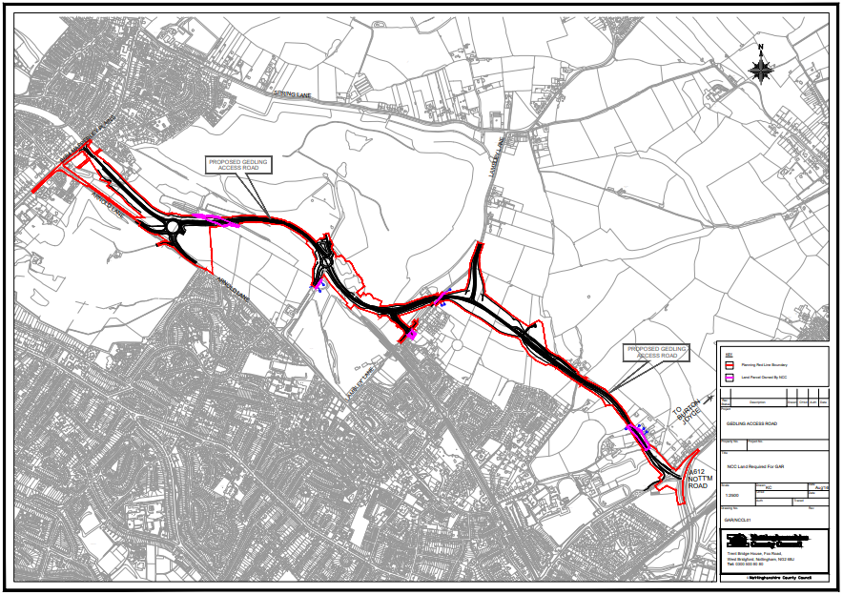
2.2.2 Neighbourhood CIL
Under the Community Infrastructure Levy (Amendment) (England) (No. 2) Regulations 2019 a ‘meaningful proportion of CIL receipts are to be passed to local town or parish councils for the area where development takes place. This is known as the ‘neighbourhood portion’. The neighbourhood portion to be passed to the local council is set at 15% of the relevant CIL receipts (up to a cap of £100 per existing council tax dwelling) or 25% with no maximum cap specified where there is a Neighbourhood Development Plan in place. At this time there are four Neighbourhood Plans ‘made’ within Gedling Borough:
- Burton Joyce Neighbourhood Plan,
- Calverton Neighbourhood Plan,
- Linby Neighbourhood Plan, and
- Papplewick Neighbourhood Plan.
Table 5 below shows the portion of the Neighbourhood CIL Receipts which have been collected on behalf of local parishes.
Table 5. Neighbourhood CIL Awarded to Local Parishes (to the nearest £)
Year | Income
2015/16 | £0
2016/17 | £3,842
2017/18 | £12,374
2018/19 | £8,059
2019/20 | £23,808
Total | £48,083

Where there is no Parish Council, Regulation 59A of the Community Infrastructure Levy (Amendment) (England) (No. 2) Regulations 2019 places a duty on charging authorities to allocate at least 15% (up to a cap of £100 per existing council tax dwelling) or 25% (uncapped) where there is a ‘made’ Neighbourhood Plan, of CIL receipts to spend on priorities that should be agreed with the local community in areas where development is taking place. Gedling Borough Council undertake annual consultations with local residents and groups to identify and assess projects which may be suitable for Non-Parish neighbourhood funding. Where no suitable projects are identified the Neighbourhood portion is carried over to the next financial year. Further information regarding the Neighbourhood portion of the CIL can be found on the Gedling Borough Council website at https://www.gedling.gov.uk/cil/.

Gedling Borough has 11 Parishes where the Neighbourhood portion of CIL Receipts will be passed to the Parish Councils if developments take place in those areas. The Parishes cover the following areas:

- Bestwood Village;
- Burton Joyce;
- Calverton;
- Colwick;
- Lambley;
- Linby;
- Newstead;
- Papplewick;
- Ravenshead;
- St Albans, and
- Woodborough.

In accordance with the Community Infrastructure Levy (Amendment) (England) (No. 2) Regulations 2019, Parish Councils must publish their own annual reports which detail funding and expenditure for each year where they have received monies passed down through the Neighbourhood Portion through CIL.
It should be noted that the extent of the Parishes does not cover the majority of the urban area of Gedling Borough (with the exception of Colwick). This creates a gap in the coverage for the Neighbourhood portion in the Borough. When development takes place in this area Gedling Borough Council will determine, in consultation with its residents, how to expend this element of the CIL in accordance with Regulation 59F of with the Community Infrastructure Levy (Amendment) (England) (No. 2) Regulations 2019.
Below is a table showing the amount of CIL which has been collected and allocated towards the Non-Parish Neighbourhood element since the CIL was adopted.
Table 6. Non-Parish Neighbourhood CIL Collected (to the nearest £)
Year | Income
2015/16 | £0
2016/17 | £2,476
2017/18 | £50,397
2018/19 | £91,344
2019/20 | £46,423
Total | £190,640

To date Gedling Borough Council has provided funding to three pieces of infrastructure through the Non-Parish Neighborhood portion. These include:

Car Park extension at Gedling Country Park
The sum of £100,000 was award to extension of the car park at Gedling Country Park, Mapperley in 2019.
Gedling Country Park was opened in 2015 and provides approx. 580 acres of open space, footpaths, and wildlife for members of the public to enjoy. Due to the growing popularity of the Gedling Country Park it was considered necessary to increase the capacity of the car park to the front of the site.
A Planning Application, reference 2019/0752, which sought permission for the “Creation of 100 additional car parking spaces. New connecting footpaths, landscaped bunds, and suds drainage system.” was granted Conditional Permission on the 22nd November 2019. Construction of the car park extension was completed early 2020.
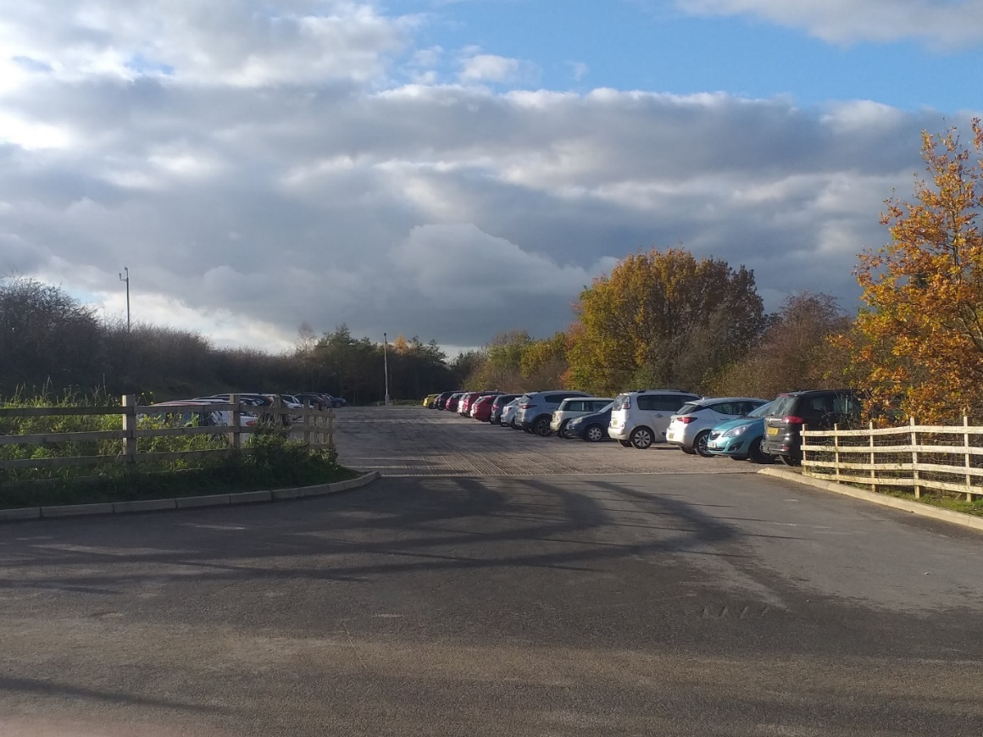

Changing Room Facilities at Lambley Lane
In 2019 a total of £40,000 was awarded to the replacement of the existing changing room facilities at Lambley Lane Recreation Ground.
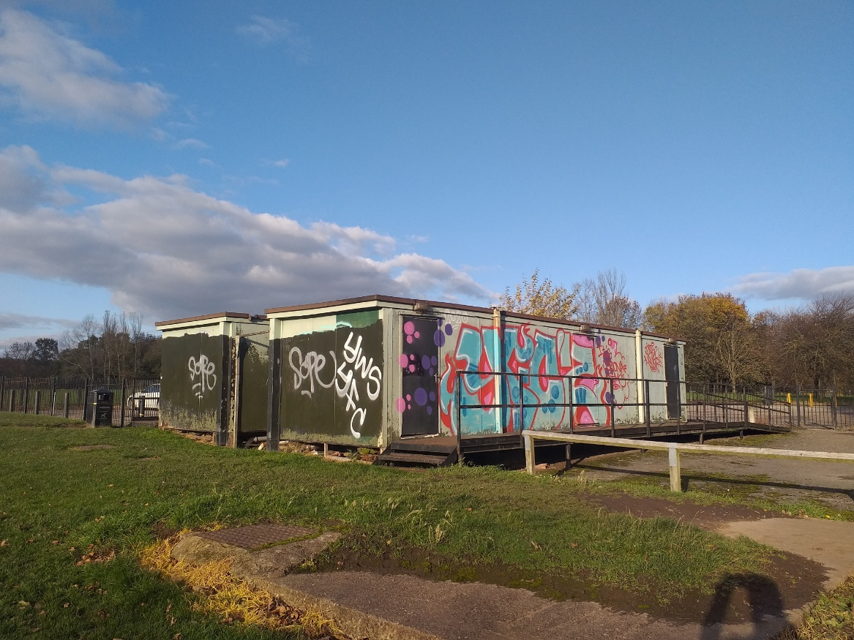
Works are expected to be completed in August 2021.

New Lighting at Cinderpath
In 2018, an award of £3,500 was granted to deliver new lighting as part of the Cinderpath scheme in Netherfield.
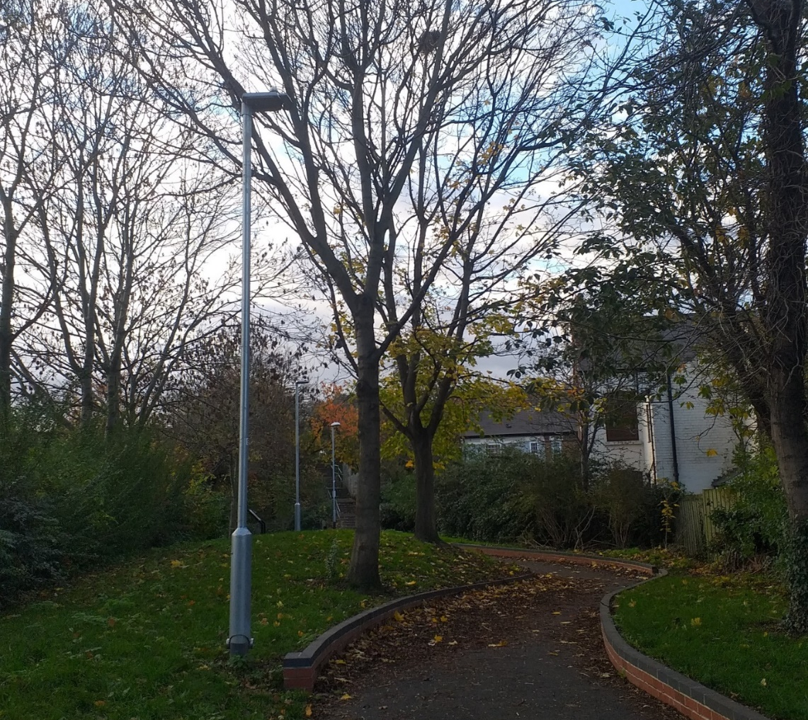
Works were completed on the lighting for the Cinderpath in 2018.
To date a total of £143,500 in CIL receipts has been awarded to infrastructure projects in accordance with Regulation 59F of the Community Infrastructure Levy (Amendment) (England) (No. 2) Regulations 2019. At the end of the financial year 2019/20 £47,140 remain with Gedling Borough Council for allocation towards the funding of future nominated projects.

Figure 2. Pie Chart showing allocation of Non-Parish Neighbourhood Funding

2.2.3 CIL Administration Portion
The remaining 5% of monies collected through CIL Receipts is made available for Charging Authorities to cover the administrative costs associated with implementing and enforcing the CIL.
To date a total of £77,277 has been collected towards covering the costs of operating the CIL within Gedling Borough Council. Table 7 below shows a breakdown of the annual receipts collected towards this portion of the CIL.
Table 7. Administration CIL Collected (to the nearest £)
Year | Income
2015/16 | £0
2016/17 | £2,106
2017/18 | £20,861
2018/19 | £33,134
2019/20 | £21,176
Total | £77,277

3 SECTION 106 OBLIGATIONS
Gedling Borough Councils approach to planning obligations is set out within the Aligned Core Strategy 2014 (Part 1 Local Plan), the Local Planning Document 2018 (Part 2 Local Plan) and Gedling Borough Councils Planning Obligations Protocol 2014. Priorities which should be considered when negotiating planning applications include factors such as Affordable Housing, Open Space, Education and Primary Healthcare.
More detailed guidance regarding how obligations are calculated can be found in Gedling Borough Councils Supplementary Planning Documents and Guidance on the Gedling Borough Councils website at https://www.gedling.gov.uk/resident/planningandbuildingcontrol/planningpolicy/adoptedlocalplanandpolicydocuments/.
3.1 New Section 106 Agreements Signed
There have been several new planning permissions granted for larger developments which were subject to Section 106 Agreements. These include:
Table 8. List of New Section 106 Agreements
App Ref | Location | Obligations
2018/0549 | Carlton Police Station, Cavendish Road, Carlton, Nottinghamshire, NG4 3DZ | Local Employment Skills Plan.  Primary Healthcare Contribution £21,357 (Index Linked).*  Open Space Contribution £61,422.95 (Index Linked).*  Affordable Housing provision of 13 Affordable Units on-site.*  (*provision subject to re-assessment of viability if development not substantially complete within 48 months)
2018/1143 | Land at Flatts Lane, Calverton, Nottinghamshire | Affordable Housing provision of 20% Affordable Units on-site.  Local Employment and Skills Plan.  Open Space LAP or LEAP Capital and Maintenance Contribution £193,798 (Index Linked).  Open Space Amenity Spaces Capital and Maintenance Contribution £58,311 (Index Linked).  Primary Healthcare Contribution £45,300 (Index Linked).
2017/0155 | Land at Brookfields Garden Centre, Mapperley Plains, Nottingham, NG3 5RW | Affordable Housing provision of 30% Affordable Units on-site.  Local Employment and Skills Plan.  Primary Healthcare Contribution £45,300 (Index Linked).  Open Space Contribution £98,093.32 (Index Linked).
2019/0876 | 1 Lendrum Court, Burton Joyce, Nottinghamshire, NG14 5BB | To enter into Nomination Agreement regarding Affordable Housing units on-site.
2018/0607 | Land North West, Park Road, Calverton, Nottinghamshire | Affordable Housing provision of 20% Affordable Units on-site.  Local Employment and Skills Plan.  Primary Healthcare Contribution £196,745.00 (Index Linked).  Open Space Contribution £35,000.00 (Index Linked).
2019/0770 | 84-86 Chapel Lane, Ravenshead, Nottingham | Open Space Contribution £41,346.80 (Index Linked).
2019/0764 | Land at Chase Farm, Mapperley Plains, Mapperley, Nottingham | Affordable Housing provision of 20% Affordable Units on-site.  Local Employment and Skills Plan.  Primary Healthcare Contribution £4,926.25 (Index Linked).  Open Space Contribution £227,407.40 (Index Linked).
2020/0009 | Millbeck House, Oakdale Road, Arnold, Nottinghamshire, NG5 8BX | Local Employment and Skills Plan.

A copy of each Section 106 Agreement and other public documents relevant to each Planning Application can be viewed electronically on the planning portal at https://pawam.gedling.gov.uk/online-applications/.
3.2 Section 106 Capital Contributions Overview
For the financial year 2019/20, a total of £239,851 capital was received in Section 106 Contributions with expenditure rising to £405,734.
Table 9 sets out the total amount received from S106 Contributions and the amount of Expenditure over the last three financial years.
Table 9. Overview of Annual Section 106
Year | Capital Contributions Received | Expenditure
2017/18 | £128,895.96 | £17,079.00
2018/19 | £266,066.78 | £195,164.00
2019/20 | £239,850.75 | £405,733.50

As shown in figure 4 below, Gedling Borough Council has increased its expenditure of Section 106 Contributions for the past three years running. This is in keeping with the Borough Councils objective to ensure that appropriate infrastructure is delivered on site to mitigate against the impacts of new development and to meet the needs of its residents and local communities, and to ensure that contributions are spent in a timely manner.
Figure 3. Section 106 Income and Expenditure since 2017/18

3.3 Capital Contributions retained at end of Financial Year 19/20
Contributions collected through a Section 106 agreement usually have a clause stating the timeframe in which the contribution is to be expended. Currently there are no S106 contributions which have exceeded the timeframe and plans are in place to ensure that the contributions are expended prior to the repayment dates set.
In the majority of S106 agreements the payback period is usually 10 years however these clauses can range between 5 – 10 years.
Table 10 below details the Capital Contributions which have been retained at the end of the financial year 2019 – 2020. These monies have yet to be allocated to a specific scheme or project.

Table 10. Capital Contributions held at 31st March 2020.
Site | Application Reference | S106 Received | Contributions Held | Provision | Deadline to for expenditure
Spring Lane | 2007/0748 | 2014 | £25,124 | Affordable Housing | 2024
 |  |  | £76,079 | Open Space
Land at Wighay Road | 2014/0950 | 2016 | £94,822 | Open Space | 2026
 |  |  | £560,567 | Affordable Housing
 |  |  | £21,741 | Healthcare
Land at Stockings Farm | 2010/0437 | 2016 | £435,232 | Healthcare | 2026
Bradstone Drive, off Spring Lane | 2014/0740 | 2017 | £23,903 | Healthcare | 2028
Land North of Papplewick Lane, Linby | 2013/1406 | 2017 | £37,346 | Healthcare | 2027
Land Off Cavendish Road | 2014/0559 | 2017 | £35,243 | Open Space | 2027
Land North of Papplewick Lane, Linby | 2013/1406 | 2018 | £215,568 | Affordable Housing | 2028
Land South of Woodchurch Road | 2018/0911 | 2018 | £28,518 | Open Space | 2028
Land at Teal Close, Netherfield | 2013/0546 | 2020 | £111,237 | Healthcare | 2030
Land West of Westhouse Farm | 2014/0238 | 2019 | £27,818 | Healthcare | 2029
Land Between Main St and Hollinwood | 2012/0941 | 2019 | £99,536 | Open Space | 2029
Total |  |  | £1,792,734

Figure 5 below provides a breakdown of all the contributions currently held by Gedling Borough Council per service provision.
Figure 4. Pie Chart showing S106 Contributions held per type of provision

3.4 Section 106 Capital and Revenue Expenditure
In 2019/20 Section 106 Contributions totalling £405,733.50 were spent on infrastructure projects across the borough. Table 11 indicates which developments the contributions were drawn down from and what projects they were allocated to.

Table 11. Capital Contributions expended during 2019/20.
Site | Application Reference | S106 Contribution Received | Amount Spent | Provision/Project Funded
Bradstone Drive off Spring Lane | 2014/0740 | 2017 | £42,639.00 | Westdale Lane Surgery, 20-22 Westdale Lane, Gedling  Extension to practice, providing 4 No. additional consultation rooms.
Ashwater Drive, Mapperley | 2010/1022 | 2017 | £133,330.59 | Westdale Lane Surgery, 20-22 Westdale Lane, Gedling  Extension to practice, providing 4 No. additional consultation rooms.
Land Off Cavendish Road, Carlton | 2014/0559 | 2017 | £23,862.88 | Westdale Lane Surgery, 20-22 Westdale Lane, Gedling  Extension to practice, providing 4 No. additional consultation rooms.
Spring Lane Mapperley | 2007/0748 | 2014 | £63,537.68 | Gedling Country Park, Seating Area, Viewing Platforms and Car Park Extension
7-9 Chapel Lane | 2007/0623 | 2010 | £35,298.48 | Demolition of Burton Road
Spring Lane Mapperley | 2007/0748 | 2014 | £106,876.40 | Demolition of Burton Road
Clearance of Historic Balance | Various |  | £188.47 | Gedling Country Park, Seating Area, Viewing Platforms and Car Park Extension
Total |  |  | £405,733.50
This is in keeping with the aim of ensuring that the delivery of appropriate infrastructure is provided to support the development of additional homes within the Borough.
As well as the collection and expenditure of capital contributions, it is not uncommon for Section 106 Agreements to require the payment of revenue contributions towards the ongoing maintenance of infrastructure which is provided. These payments are typically agreed for a period of 10 years. The majority of revenue contributions which are collected by Gedling Borough Council relate primarily to ongoing maintenance works on Open Spaces sites that the Council have adopted. Table 12 below sets out revenue contributions which have been collected by the Local Authority and the developments they have been spent on thus far.
Table 12. Revenue Contributions Received
Site | Date Received | Balance at 1st April 2019 | Annual Payment 2019/20 | Remaining Balance at 31st March 2020
Spring Lane | 2006 | £3,413.20 | £568.86 | £2,844.34
Park Road, Bestwood | 2006 | £17,880.41 | £0 | £17,880.41
Edison Way, Arnold | 2007 | £15,637.62 | £5,212.54 | £10,425.08
Downham Close, Arnold | 2008 | £4,951.70 | £825.28 | £4,126.42
Emerys Road | 2008 | £2,316.38 | £2,316.38 | £0.00
Brooklands Drive | 2008 | £4,309.84 | £1,445.50 | £2,864.34
Arnold View Primary School | 2009 | £17,320.93 | £2,474.42 | £14,846.51
Burton Road, Gedling | 2009 | £4,582.03 | £763.34 | £3,818.69
188-194 Mapperley Plains | 2016 | £13,324.55 | £1,903.51 | £11,421.04
333-339 Mapperley Plains | 2016 | £16,861.60 | £2,408.80 | £14,452.80
Spring Lane | 2017 | £88,460.31 | £11,057.54 | £77,402.77
Land at Teal Close, Netherfield | 2018 | £2,549.67 | £0.00 | £2,549.67
Total |  | £191,608.24 | £28,976.17 | £162,632.07

3.5 Section 106 Monitoring Fees
The Community Infrastructure Levy (Amendment) (England) (No. 2) Regulations 2019 introduced a provision for Local Authorities to insert Monitoring Clauses into future Section 106 Agreements. These clauses allow fees to be levied to support the costs of monitoring and reporting on the delivery of Section 106 planning obligations.
Whilst the amendments to the Regulations allows for monitoring fees to be levied, any such fee must be both fair and reasonable based on the Local Authorities estimates of the actual costs of monitoring the agreement. The Borough Council has an adopted policy –https://democracy.gedling.gov.uk/documents/s16689/Appendix%201%20Monitoring%20Fee%20Ststement.pdf.
To date Gedling Borough Council have sought Monitoring Fees in relation to nine developments. A list of these developments and the relevant monitoring fees are detailed below.
Table 13. Section 106 Agreements with Monitoring Fees
Site | Date S106 Signed | Value of Monitoring Fee | Status
Land West Of Westhouse Farm, Moor Road, Bestwood, Nottinghamshire | 21.03.2019 | £1,260.00 | Received
Carlton Police Station,  Cavendish Road, Carlton, Nottingham, NG4 3DZ | 29.03.2019 | £315.00 | Payment Due
Land North West, Park Road, Calverton, Nottinghamshire | 18.02.2020 | £2,520.00 | Not Commenced
Land On Flatts Lane, Calverton, Nottinghamshire | 03.03.2020 | £2,835.00 | Not Commenced
Land at Orchard Close, Burton Joyce, Nottinghamshire | 26.03.2020 | £2,520.00 | Not Commenced
Land at Brookfields Garden Centre, Mapperley Plains, Nottingham, NG3 5RW | 26.03.2020 | £2,205.00 | Not Commenced
84-86 Chapel Lane, Ravenshead, Nottingham | 03.07.2020 | £1,260.00 | Payment Due
Land at Chase Farm, Mapperley Plains, Mapperley, Nottingham | 09.07.2020 | £1,890.00 | Not Commenced
Land to the West of Mapperley Plains, Mapperley | 08.10.2020 | £1,890.00 | Received
Total |  | £16,695.00

3.6 Non-Monetary Contributions
In some instances, financial contributions may not be deemed necessary to mitigate against the impacts of a development. Instead it may be considered that the provision of on-site infrastructure such as Affordable Housing or, the agreement of future plans such as local employment schemes may be sufficient.
Table 14 details developments approved during the reporting year which include a provision to provide Affordable Housing on site.
Table 14. Provision of Affordable Housing 2019/20
Site Address | Application Reference | Date S106 Signed | Affordable Housing Obligation
Land North West, Park Road, Calverton, Nottinghamshire | 2018/0607 | 18.02.2020 | 20% of dwellings to be Affordable Housing Units (70% Affordable Rented Units and 30% Intermediate Housing)
Land On Flatts Lane, Calverton, Nottinghamshire | 2018/1143 | 03.03.2020 | 20% of dwellings to be Affordable Housing Units (70% Affordable Rented Units and 30% Intermediate Housing)
Land at Brookfields Garden Centre, Mapperley Plains, Nottingham, NG3 5RW | 2017/0155 | 26.03.2020 | 30% of dwellings to be Affordable Housing Units (70% Affordable Rented Units and 30% Intermediate Housing)
Land at Orchard Close, Burton Joyce, Nottinghamshire | 2018/1034 | 26.03.2020 | 4 dwellings to be Affordable Housing Units (3 Affordable Rented Units and 1 Intermediate Housing)

Several Planning Permissions approved during the 2019 / 20 financial year include a requirement to submit an Employment and Skill Plans as part of a Section 106 Obligation. Table 13 details the developments which require such obligations.
Table 13. Employment and Skills Plans Agreed 2019/20
Site | Date S106 Signed
Land North West, Park Road, Calverton, Nottinghamshire | 18.02.2020
Land On Flatts Lane, Calverton, Nottinghamshire | 03.03.2020
Land at Brookfields Garden Centre, Mapperley Plains, Nottingham, NG3 5RW | 26.03.2020
Land at Orchard Close, Burton Joyce, Nottinghamshire | 26.03.2020

3.7 Monies Borrowed
No Section 106 monies were spent repaying money borrowed during the financial year 2019/20.

4 GOING FORWARD – PLANNED EXPENDITURE
In accordance with the latest amendments to the CIL Regulations, the IFS outlines the future priorities in terms of expenditure over the next reporting period (2020/21).
The amount of CIL receipts generated in any given financial year is dependent upon the implementation of planning permissions and phasing of developments. Whilst it is possible to calculate the amount of CIL receipts expected through the totalling of Liability Notices generated, this will only ever be a theoretical figure as payment only becomes due upon the commencement of development.
Contributions generated through Section 106 Agreements must be spent in accordance with the terms set out within each Agreement (as negotiated during the planning application process). These terms will often have several trigger points, such as number of residential units occupied, which will cause the payment to become due. In this way, funding obtained through Section 106 agreements are heavily reliant upon the phasing and delivery of development and can vary greatly on a site by site basis, making it difficult to accurately forecast future income.
4.1 Strategic CIL
Since Gedling Borough Council first adopted the CIL in 2015 the Strategic portion of CIL Receipts have been ring-fenced for the provision of the Gedling Access Road (GAR). The GAR remains a vital piece of infrastructure to support growth in the area and provide greater connectivity between the central urbanised area of the Borough such as Mapperley and Arnold, and more rural settlements such as Burton Joyce and Stoke Bardolph. Until such a time as the funding gap for the GAR has been reached, CIL receipts for the Strategic element will continue to be ring-fenced for this piece of infrastructure.
Once the funding gap for the GAR has been reached the focus will shift towards secondary school contributions at Gedling Colliery / Chase Farm and Top Wighay Farm strategic sites. It is envisaged that the interim funding gap for Secondary School facilities required for these two developments can be reduced through education contributions delivered through Section 106 Agreements. Expenditure on a possible visitor centre at Gedling Country Park has also been approved.
4.2 Neighbourhood Portion CIL
The Neighbourhood CIL will continue to be spent on providing and improving existing infrastructure within the Borough. 15% of CIL receipts will continue to be allocated to the Neighbourhood portion of the CIL rising to 25% in places where a Neighbourhood Plan has been adopted.
The Neighbourhood portion of CIL receipts collected in local parishes will continue to be forwards directly to these governing bodies for allocation.
Throughout the year, local community groups and stakeholders will be able to nominate projects for the Neighbourhood portion of the CIL receipts which are collected within non-parish areas. Submissions can be made by completing the electronic form on the Gedling Borough Council website at https://apps.gedling.gov.uk/forms/default.aspx?formid=86.
At the beginning of September an annual review of all the projects nominated will commence and includes a publication of a Local Infrastructure Schedule, a comprehensive project assessment followed by a public consultation, and a final report identifying which if any projects have been successful. If no projects are nominated or deemed appropriate the Neighbourhood CIL will be carried over to the next financial year.
Examples of types of Infrastructure which may be appropriate include:
- Improvements to local open spaces;
- Street improvements;
- Drainage improvements;
- Town centre regeneration and
- Recreational facilities.
It is important that any project which is nominated is able to demonstrate how it fulfils a need created by new development within the area and, should wherever possible, show availability to provide match funding through other revenue streams.

4.3 Section 106 Contributions
The Gedling 2020/21 capital programme sets out the future spending priorities of Gedling Borough Council. Currently £63,600 of Section 106 Contributions have been allocated towards infrastructure projects in the next financial year. The projects which have been identified so far as suitable for Section 106 funding are detailed in table 14 below.
Table 14. Section 106 Contributions 2020/21 Allocations
Affordable Housing
Burton Road £12,000 from Spring Lane 2007/0748 contributions.
Open Spaces
Gedling Country Park £16,000 from Spring Lane 2007/0748 contributions.
Lambley Lane Changing Rooms £35,000 from Cavendish Road 2014/0559 contributions.
Healthcare
No funding committed for 20/21 to date.
Education
Education Contributions are requested and secured by Nottinghamshire County Council. The County Council are required to draft their own Infrastructure Funding Statement reporting on financial contributions received through S106 Agreements. A copy of this document will be available for viewing on Nottinghamshire County Councils website.

Careful consideration will be given to remaining Section 106 Contributions which are being held by Gedling Borough Council. These remaining sums will be monitored and allocated when appropriate to infrastructure projects which accord with the legal definitions within the corresponding S106 agreements.

5 Infrastructure List
Table 15. The Infrastructure List
Community Infrastructure Levy
Construction of Gedling Access Road to facilitate Gedling Colliery / Chase Farm development. | To be funded through Strategic portion of CIL Receipts collected.
Secondary School Contributions at Gedling Colliery / Chase Farm and Top Wighay Farm developments. | To be funded through Strategic portion of CIL Receipts collected.
Gedling Colliery Country Park Visitors Centre | To be funded through Strategic portion of CIL Receipts collected.
Annual assessment of suitable Infrastructure projects identified in accordance with Regulation 59F of the Community Infrastructure Levy (Amendment) (England) (No. 2) Regulations 2019. | To be funded through the Neighbourhood portion of CIL Receipts collected.
Section 106 Contributions
Provision of Affordable Housing Units either on-site of through capital contributions. | To be secured through Section 106 Obligations.
Provision of Open Spaces including new infrastructure and improvements to existing sites. | To be secured through Section 106 Obligations.
Provision for Primary Healthcare including new infrastructure and improvements of existing surgeries. | To be secured through Section 106 Obligations.
Any other future infrastructure which is deemed necessary, in accordance with the Community Infrastructure Levy (Amendment) (England) (No. 2) Regulations 2019 | To be secured through Section 106 Obligations.

The above is not a final account of all infrastructure that may be funded through Planning Obligations. The Infrastructure List will be monitored and may be updated accordingly to represent new projects that are identified in the future.
If you have any further queries or comments about this statement, please do not hesitate to contact us via email at CIL@gedling.gov.uk or phone on 0115 901 3731.

